Tracking a Time-Varying Sinusoid Using the Extended Kalman filter

Consider what one might call a ‘real-world’ sinusoid:

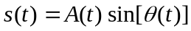 (1)
where 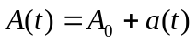 and 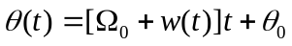.

Both the amplitude and frequency are subject to small amounts of jitter. The goal here is to use the extended Kalman filter (EKF) to estimate the time-varying amplitude and frequency. If we define the state 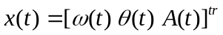, we may then write
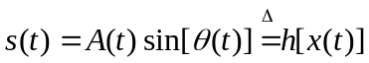. (2)

Development of the Discrete-Time State Equation for Amplitude & Frequency Jitter

We will now assume that the amplitude and frequency jitter processes may be modeled as Gauss-Markov processes; that is:

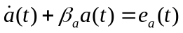 and 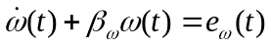.

The impulse responses associated with these ‘dynamical systems’ are:

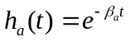 and 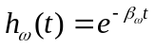.

Suppose now that we are sampling (1) at a sampling interval Δ. We then have

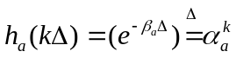 and 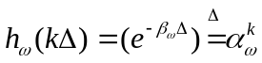.

The resulting sampled GM processes become AR(1) processes:

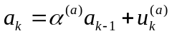 and 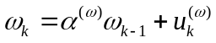 (3)

where 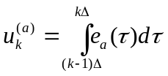 is a discrete-time white noise process with variance 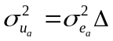, and where 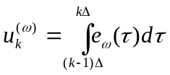 is a discrete-time white noise process with variance 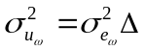. To obtain the discrete-time form for 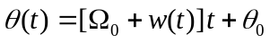 , we observe that

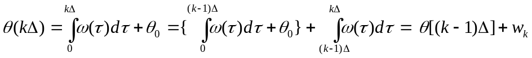
where

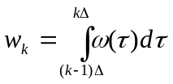. If we now assume that 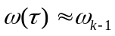for 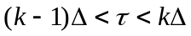, we obtain

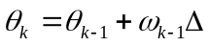. (4)

The discrete-time state jitter dynamics are then

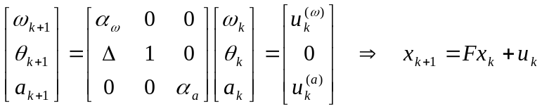. (5)

If at this point, we assume no knowledge of the dynamics of the frequency and amplitude jitter, then we can simply specify 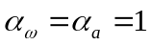. In this case, we must resort to ‘trial and error’ in order to find the appropriate values contained in

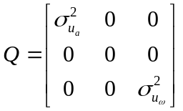.

Development of the Extended Kalman Filter Measurement Equation.

Here, we will assume that the sinusoid is contaminated by white noise. If this is not the case, then one must incorporate the noise dynamics into the state equation. The measurement equation is

where using a first order Taylor expansion gives:

The partial derivatives are evaluated at 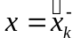, and are given by

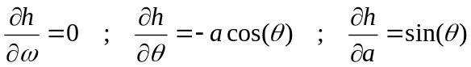.

Hence,

or
.

The last term acts as a deterministic input in the measurement equation. Since we have shown in the lecture on deterministic inputs [eqn. (2b)] that the only effect of this input is to include it in the estimate 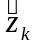in the Kalman gain equation, we can simply include the more accurate 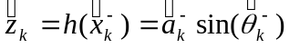

% PROGRAM NAME: sinegen.m
%PURPOSE: generate a realization of a t.v. sinusoid+noise
%=======================
npts=6000; % LENGTH OF REALIZATION
ntot=npts + 500;
%===============================================================
% GENERATION OF TIME-VARYING SINUSOID with AR(1) Ampl. & Freq.
% ==============================================================
% NOMINAL AMPLITUDE AND FREQUENCY:
a0=1.0; %nominal amplitude
w0=2*pi*0.2; % nominal frequency
%======================
sea=0.01; % amplitude driving noise sigma
sew=0.01; % angular frequency driving noise sigma
sea2=sea^2;
sew2=sew^2;
%=======================
% Generation of white processes
eda=sea*randn(1,ntot);
edw=sew*randn(1,ntot);
% Compute variances of a(t) and w(t)for use in EKF
sa2=sea2/(1-0.9^2);
sw2=sew2/(1-0.95^2);
%=====================
% Specify Initial Conditions
da(1)=eda(1);
dw(1)=edw(1);
theta(1)=0;
a(1)=a0;
w(1)=w0;
% Generate SIGNAL Realization
for t=2:ntot
da(t)=0.9*da(t-1)+eda(t);
a(t)=a0 + da(t);
dw(t)=0.95*dw(t-1)+edw(t);
w(t) = w0 + dw(t);
theta(t) = theta(t-1) + w(t);
end
%=====================
%Plot True Freq. and Ampl.
ftrue=w(501:ntot)/(2*pi);
atrue=a(501:ntot);
figure(1) % FIGURE 1
plot(ftrue)
title('Actual T.V. SINUSOID Frequency')
xlabel('Time [sec]')
ylabel('Frequency [Hz]')
pause
figure(2) % FIGURE 2
plot(atrue)
title('Actual T.V.SINUSOID Amplitude')
xlabel('Time [sec]')
ylabel('Amplitude')
pause
% Compute and plot T.V. Sinusoid Realization
s=a.*sin(theta);
s=s(501:ntot);
figure(3) % FIGURE 3
plot(s)
title('T.V. Sinusoid s(t) with A=1 & w=0.2')
pause
% =======================================================
% ADDITIVE NOISE REALIZATION AND PSD
% =======================================================
sn=0.5; % additive AR noise sigma of white noise input
n=sn*randn(1,ntot);
sn2=sn^2;
% Generate AR(2) Noise Process
nar(1)=n(1);
nar(2)=n(2);
a1=-1.6*cos(pi/5);
a2=0.64;
% Compute and Plot Noise PSD
delf=1/2048;
fvec=0:delf:0.5-delf;
den=fft([1 a1 a2],2048);
den=den(1:1024);
ARspec=sn2*(abs(den)).^-2;
ARspecdB=10*log10(ARspec);
figure(4) % FIGURE 4
plot(fvec,ARspecdB)
ylabel('dB')
xlabel('Frequency (Hz)')
title('AR(2) Noise PSD')
pause
for t=3:ntot
nar(t)=-a1*nar(t-1)-a2*nar(t-2)+n(t);
end
n=nar(501:ntot);
% =======================================================
% CONSTRUCTION OF MEASUREMENT PROCESS REALIZATION
% =======================================================
z=s + n;
figure(5) % FIGURE 5
nvec=1:npts;
plot(nvec,z, 'b')
hold on
plot(nvec,s,'m')
hold off
title('T.V. Sinusoid with & without AR(2) Noise')
[1 a1 a2]

% PROGRAM NAME: sinekfdelt.m
% PURPOSE: Track a t.v. sinusoid
% REQUIRED INPUT: from program sinegen.m
npts=length(z);
%======================================
% Model Matrices
Is=[1 0 0 ;1 1 0;0 0 1];
In=[1 0;0 1];
I=[Is zeros(3,2);zeros(2,3) In];
Phis=[1 0 0 ; 1 1 0 ; 0 0 1]; %signal Phi
Phin=[-a1 -a2;1 0]; %noise Phi
Phi=[Phis , zeros(3,2);zeros(2,3) , Phin];
Qs=[sw2 sw2/2 0 ; sw2/2 sw2/4 0 ; 0 0 sa2];
Qn=[sn2 0;0 0];
Q=[Qs , zeros(3,2);zeros(2,3) , Qn];
R=sn2;
%R=0;
%=====================================
% EKF Initial Conditions
xms=[2*pi*0.2;0;1];
xmn=[0 ; 0];
xm=[xms ; xmn];
x=xm;
Pm=Q;
%====================================
% EKF Loop
for k=1:npts
h2=xm(3)*cos(xm(2));
h1=0;
h3=sin(xm(2));
Hs=[h1 h2 h3];
Hn=[1 0];
H=[Hs , Hn];
K=Pm*H'*(H*Pm*H' + R)^(-1);
zm=xm(3)*sin(xm(2));
xhatk=xm + K*(z(k) - zm);
x=[x,xhatk];
P=(I - K*H)*Pm;
xm=Phi*xhatk;
Pm=Phi*P*Phi' + Q;
end
x=x(:,2:npts+1);
fhat=x(1,:)/(2*pi);
ahat=x(3,:);
thetahat=x(2,:);
figure(4)
plot(fhat);
title('EKF Estimate of T.V. Frequency')
xlabel('Time [sec]')
ylabel('Frequency [Hz]')
pause
figure(5)
plot(ahat)
title('EKF Estimate of T.V. Amplitude')
xlabel('Time [sec]')
ylabel('Amplitude')
%=====================
% Reconstruct Signal Estimate
shat=ahat.*sin(thetahat);
figure(6)
plot(shat)
hold
plot(z,'m')
title('Comparison of Raw Data and EKF-Estimate of Sine')

